 |  |  |  |  |  | Total page | 6
 |  |  |  |  |  | Doc No | AP-SC9179
 |  |  |  |  |  | Rev. | 1.0
文件名稱 |  | SC-9179 FM Radio Module Application Note-
版次 | 生效日 |  | ECN No. | 制修訂者 | 修訂內容概要
1.0 |  |  |  | 彭成銘

一.產品說明：
SC9179 FM Radio System :

TR1001(PLL)+7088(TUNER)+(搭配4051多工器IC作數位音控選擇:8段選擇) +MCU(TM87P08)+2401(EEPROM);推耳機應用。

可切換類比及數位音量(皆為MONO)。
有記憶及選擇電台功能,LCD顯示,可單步SCAN及AUTO SCAN。
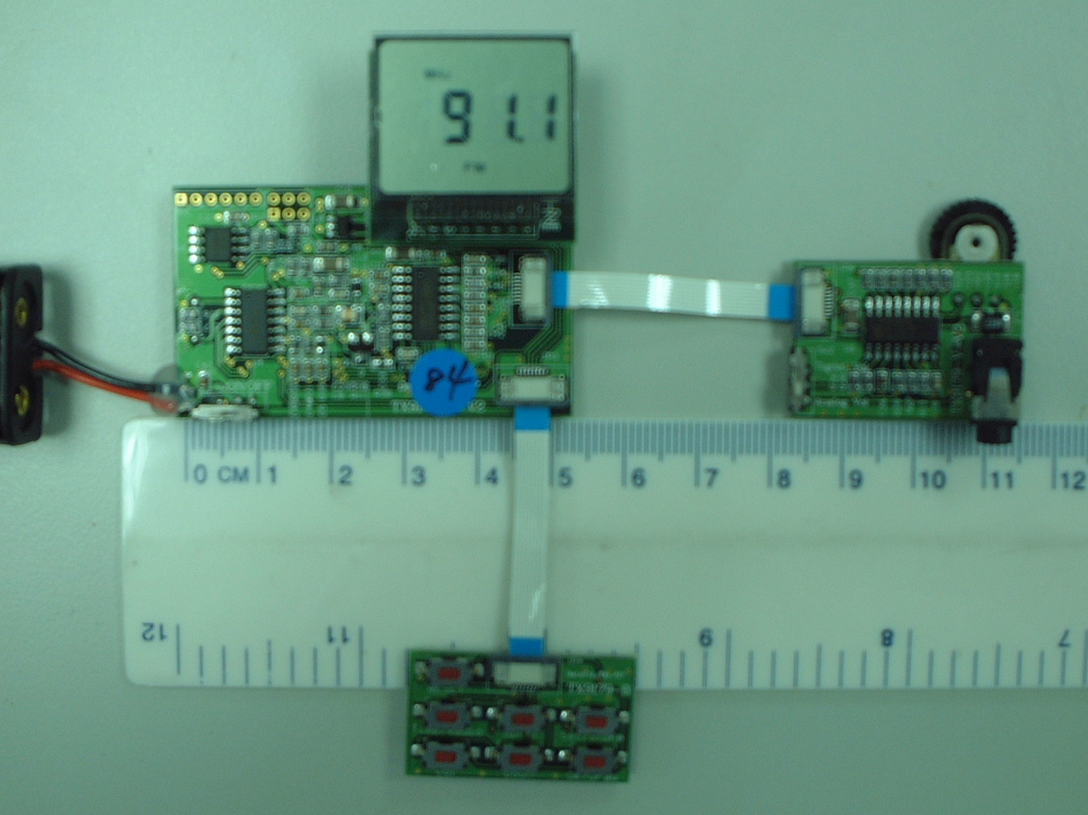

二.工作原理：
- 工作電壓:2.4~3.6V
- 示意圖:

TENX MCU
FM Module
TR1001+7088
Audio Out
Lock Detector
PA
SPK

LCD Display
ANT
Mute

Clock
Data
Enable

SC9179

三.應用實例:
可應用在萬年曆、計步器、可攜式radio、禮品radio應用…等等

四.BOM List:

TENX SC9179
Description | Quality | Location | TYPE
Capacitor
2P | 1 | C22 | SMD
15P | 2 | C1,C2 | SMD
30P | 3 | C16,C17,C49 | SMD
120P | 1 | C42 | SMD
180P | 1 | C33 | SMD
220P | 2 | C14,C41 | SMD
330P | 1 | C43 | SMD
470P | 1 | C40 | SMD
1000P | 3 | C21,C23,C39 | SMD
1800P | 1 | C36 | SMD
2.2N | 1 | C32 | SMD
3.3N | 2 | C34,C35 | SMD
10N | 1 | C25 | SMD
22N | 1 | C31 | SMD
47N | 1 | C30 | SMD
0.1U | 17 | C3,C4,C5,C6,C7,C8,C9,C10,C11,C12,C13,C15,C27,C45,C46,C47,C48 | SMD
0.22U | 1 | C24 | SMD
1U | 1 | C26 | SMD
10U (1206) | 5 | C18,C19,C20,C37,C44 | SMD
Resistor
0 | 2 | R9,R37 | SMD
100 | 1 | R18 | SMD
1.2K | 1 | R32 | SMD
5.6K | 1 | R19 | SMD
7.5K | 1 | R29 | SMD
8.2K | 1 | R20 | SMD
10K | 5 | R4,R5,R6,R7,R8 | SMD
22K | 6 | R12,R13,R14,R15,R16,R17 | SMD
27K | 1 | R31 | SMD
30K | 1 | R28 | SMD
51K | 3 | R1,R2,R3 | SMD
VR 50K | 1 | R36 | DIP
75K | 1 | R27 | SMD
100K | 2 | R10,R11 | SMD
150K | 2 | R26,R30 | SMD
220K | 1 | R25 | SMD
300K | 1 | R21 | SMD
430K | 1 | R24 | SMD
1M | 2 | R23,R33 | SMD
2M | 1 | R22 | SMD
10M | 1 | R34 | SMD
Inductor
56n | 1 | L1 | SMD
4.7u | 2 | L2,L3 | SMD
Other
BB178 | 1 | D1 | SMD
S9018 | 1 | Q1 | SMD
2N3904 | 1 | Q2 | SMD
S9014 | 1 | Q3 | SMD
S9012 | 1 | Q4 | SMD
Switch | 2 | SW1,SW2 | DIP
32.768KHz | 1 | Y1 | DIP
4M | 1 | Y2 | DIP
24C02/24LC02 | 1 | U1 | SMD
LQFP80_TX1396 | 1 | U2 | SMD
LCD16 | 1 | U3 | DIP
TR1001 | 1 | U4 | SMD
RT9167-CB | 1 | U5 | SMD
4051 | 1 | U6 | SMD
TDA7088 | 1 | U8 | SMD
SMD Buttom | 7 | S1,S2,S3,S4,S5,S6,S7 | SMD
HEADER 6 (Pitch 2mm) | 1 | JP1 | DIP
HEADER 2X3 (Pitch 2mm) | 1 | JP2 | DIP
FPC_8P (Pitch 0.5mm)下接式 | 4 | JP3,JP4,JP5,JP6 | SMD
FFC_8P (Pitch 0.5mm)同向 | 2 |  | DIP
HEADER 2X8 (Pitch 2mm)公座 | 1 | JP7 | DIP
HEADER 2X8 (Pitch 2mm)母座 | 1 | JP8 | DIP
EAR PHONE (Mini 4Pin) | 1 | LS1 | DIP
3V (Battary box) | 1 | BT1 | DIP

UTC 代理商 豐宏 呂正義 02-66209911 #232 0916-005371
淮洋有限公司 洪先生 02-82610858
津綻 楊晉奇 02-82214998 #112 0936-235208
登壹 廖學儀 02-32346785 #323 0931-356548

五.電路圖：

**若使用立體音(雙聲)喇叭,在SC9179聲音輸出上面,若無聲音輸出,可在喇叭輸出接頭上加一個雙音轉單音的轉接頭,即可有聲音輸出(SC9179本身聲音輸出是使用在單音輸出架構)。

